**CSCI-6461**

**Computer System Architecture**

**PROJECT - Part 3 – Simulator**

**[*New Features like ability to run Program 2 and compute more*]**

**Designed by – TEAM 5**  
Avish Kaushik  
Harichandana Samudrala

GITHUB URL - <https://github.com/AvishKaushik/Simulator.git>

**Design Notes for the Simulator**

**1. Overview of the Project**

The CSA Simulator is a tool that emulates the key components of a computer system architecture, including the CPU, memory, input/output devices, and conversion utilities. The system is implemented in Java with a graphical user interface (GUI) using Swing to provide users with interactive controls for simulating CPU operations, memory management, and device interaction.

**2. System Components**

**Graphical User Interface (GUI)**

* **Java Swing-based GUI**: The GUI is created using Swing components such as JLabel and JButton to visually represent registers, memory, and control buttons.
* **Key GUI Components**:
  + **Registers and Labels**: General Purpose Registers (GPRs), Index Registers (IXRs), and the Machine Fault Register (MFR) are displayed using JLabel components.
  + **Control Buttons**: Buttons like "Store," "Load," "Reset," and "Run" allow users to interact with the system, controlling data storage, code execution, and system resets.
  + **Event Handling**: Each button has an associated event listener, which calls methods like Store(), LoadValue(), and RunProg() to execute corresponding actions.
* **Threading for Responsiveness**: The "Run" button uses a background SwingWorker thread to ensure the GUI remains responsive during long-running processes, such as executing a program.
* **Fixed Layout**: The GUI layout is manually set using setBounds() to position elements, resulting in a static layout. This could pose challenges for resizing or adapting to different screen resolutions.

**Memory Management (Memory.java)**

* **2KB Memory Array**: The memory is simulated using a short[] array with a fixed size of 2048 cells (2KB). Each cell is initialized to zero at the start.
* **Fixed Memory Size**: The memory size is currently hardcoded, which may limit flexibility for future expansion. A constructor could be added to make the memory size configurable.

**Devices Interface (Devices.java)**

* **Console Input/Output Simulation**: The device interface mimics a console using JTextArea components:
  + **ConsoleOut**: A simulated console output (printer), styled with a monospaced font (Courier New) and a green-on-black color scheme.
  + **ConsoleIn**: A single-line input area representing the console keyboard.
  + **Panels**: Panels are used to organize the components, each with a titled border for clarity.
* **Manual Layout**: The device panels use setBounds() for manual positioning, making the GUI non-responsive to window resizing.

**Number Conversion Utility (Converter.java)**

* **Binary, Decimal, and Octal Conversions**: The Converter class provides utility functions to convert numbers between binary, decimal, and octal formats, a key feature for simulating CPU operations.
  + **BinaryToDecimal()**: Converts a binary array to its decimal equivalent.
  + **DecimalToBinary()**: Converts a decimal number to its binary representation.
  + **OctToDecimal()**: Converts a octal string to a decimal number.
* **Reusability**: These conversion functions are designed to be reusable across different parts of the system, particularly in the CPU and memory handling processes.

**CPU Simulation (CPU.java)**

* **Register Management**: The CPU class manages a set of registers, including General Purpose Registers (GPRs), the Program Counter (PC), Instruction Register (IR), and more.
* **Instruction Execution**: The Execute (Memory m) method processes instructions by decoding binary opcodes and executing corresponding operations, such as loading and storing data, halting the program, and addressing operations.
  + **Opcode Handling**: A switch-case structure is used to handle various opcodes like LDR (load register), STR (store register), and HLT (halt).
* **Memory Fault Handling**: The Memory Fault Register (MFR) detects and manages memory faults. If a fault occurs, the system resets the PC and stores the fault address in memory.
* **Inheritance**: The CPU class extends the Converter class, allowing direct access to number conversion methods, which are integral for interpreting opcodes and addressing information.

**Cache Management (Cache.java)**

* **Cache Implementation**: A newly added component to improve performance by storing frequently accessed memory data.
  + **Data Retrieval**: The CPU interacts with the cache for faster access.
  + **Memory Synchronization**: Updates between the cache and main memory are managed to ensure data consistency.

**3. Key Design Considerations**

* **Manual Layout**: The reliance on setBounds() for GUI positioning results in a static layout that may not scale well with different screen sizes. Refactoring to use layout managers like GridLayout or BorderLayout would enhance the flexibility of the interface.
* **Threading for Long Operations**: The use of SwingWorker to handle long-running operations in the background ensures that the GUI remains interactive while the system executes processes like the "Run" functionality.
* **Memory Size Flexibility**: The memory is currently fixed at 2KB, which could limit future scalability. Implementing a dynamic memory allocation system or configurable memory size could provide greater flexibility in the simulator.
* **Reusability of Conversion Utilities**: The Converter class methods for binary, decimal, and hex conversions are decoupled from the specific CPU or memory logic, making them highly reusable across the system.

**4. Project Structure**

* **src/main/java**: Contains the main source code for the project.
  + **com.csa.simulator.components**: Contains various components of the simulator, including:
    - **Assembler**: Parses and loads programs.
    - **Cache**: Stores frequently accessed data for performance optimization.
    - **CacheData**: Handles data-specific logic for the cache.
    - **Converter**: Manages binary, decimal, and hex conversions.
    - **CPU**: Core CPU logic and opcode handling.
    - **Devices**: Manages I/O devices.
    - **Memory**: Manages main memory.
  + **com.csa.simulator.gui**: Contains classes related to the graphical user interface (GUI).
    - **GUI**: The main class for the user interface components.
    - **Main**: Likely the main entry point of the application.

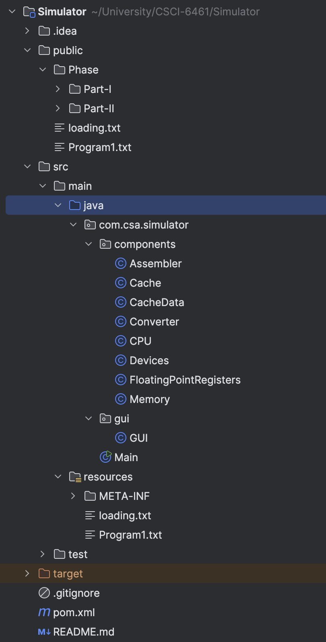

* **src/main/resources**: Contains non-code resources like configuration files.
  + **Program1.txt**: Program file to run program1.
  + **Program2.txt**: Newly added program file to run program2.
* **src/test**: (Currently empty in the image) Reserved for test cases and unit tests.
* **target**: (Generated by Maven) Holds the compiled bytecode and packaged outputs (e.g., JAR files).
* **pom.xml**: The Maven Project Object Model file, used for managing project dependencies and build configurations.
* **README.md**: Documentation file providing an overview of the project and setup instructions.
* **.gitignore**: Specifies files to be ignored by Git version control (e.g., compiled binaries or temporary files).

**5. Key Changes in the Simulator**

This section outlines the recent additions and modifications made to the CSA Simulator to enhance its functionality and performance.

1. **Cache Implementation**
   * **Introduction of Cache Component:** A new Cache component has been added to improve memory access speed by storing frequently accessed data. This reduces the latency involved in fetching data directly from main memory, thereby enhancing the overall efficiency of the simulator.
   * **Cache Synchronization:** The cache is synchronized with main memory to ensure data consistency. The simulator now retrieves data from the cache whenever possible, falling back to main memory only if the data is not available in the cache.
2. **Expanded Instruction Set**
   * **New Instructions:** The simulator now supports additional instructions, enabling it to handle a broader range of operations. This includes new arithmetic, logical, and control instructions that enhance the simulator's ability to emulate complex programs.
   * **Full Instruction Set Support:** The simulator is now capable of executing the entire instruction set as outlined in the project requirements, making it a comprehensive tool for CPU simulation.
3. **Program 1 Execution Capability**
   * **Support for Program 1:** The simulator has been updated to load and execute Program1.txt, allowing it to run test programs that takes 20 values using keyboard section and using insert button, after which it showcases nearest value to the value we enter among those 20 elements.
   * **Program Execution Flow:** The addition of Program 1 support includes enhancements to the Assembler and CPU classes, which parse and execute the instructions defined in Program1.txt, verifying the accuracy of instruction decoding and execution.
4. **Program 2 Execution Capability**
   * **Support for Program 2:** The simulator has been updated to load and execute Program2.txt, allowing it to run test programs that takes a whole paragraph having 6 or more sentences and can then find the word and list out the sentences where the word comes.
   * **Program Execution Flow:** The addition of Program 2 support includes enhancements to the Assembler and CPU classes, which parse and stores the paragraph stored in Program2.txt file and can tell the location of word in the sentences.

These key changes significantly improve the CSA Simulator’s performance, flexibility, and functionality, making it a more robust and capable tool for simulating computer system architecture.